KINDLY SPONSORED BY ‘THE NORTHERN SNOOKER CENTRE’

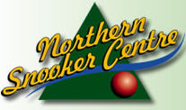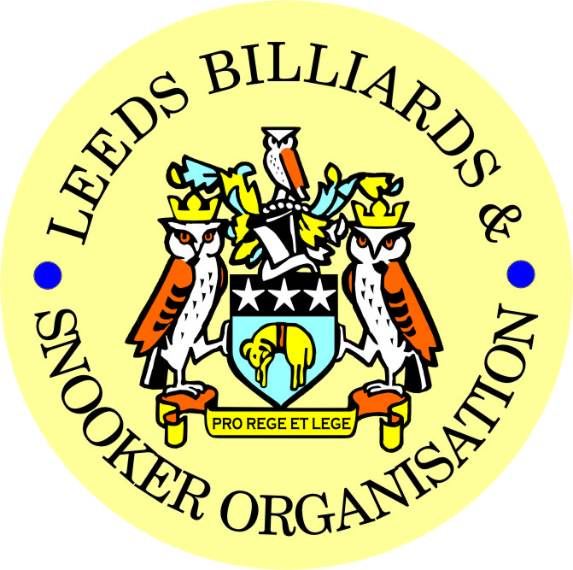

FINAL – 2018 LEEDS CITY SNOOKER CHAMPIONSHIP &
PRIZE PRESENTATION EVENING - 1

FRIDAY 22nd JUNE 2018 -7-30pm
NORTHERN SNOOKER CENTRE

** 2018 LEEDS CITY CHAMPIONSHIPS **

JUNIORS - UNDER 16’s SNOOKER:
Presented by ADT Flexibles (UK) Ltd.

WINNER: ISA ISHTIAQ | RUNNER-UP: RILEY FISHER
SEMI-FINAL: SHANNON METCALF | SEMI-FINAL: LIAM PULLEN
JUNIORS - UNDER 18’s SNOOKER:
“The Keith Weston Memorial Trophy”- Presented by ADT Flexibles (UK) Ltd.

WINNER: JOE FENTON | RUNNER-UP: ISA ISHTIAQ
SEMI-FINAL: STANLEY MOODY | SEMI-FINAL: JACK TOWNEND
JUNIOR HIGH BREAK: - “The Paul Hunter Memorial Trophy” – LIAM PULLEN (74)

INDIVIDUAL SNOOKER:

WINNER: JOHNATHAN BAGLEY | RUNNER-UP: MARK BALL
SEMI-FINAL: RYAN WALTON | SEMI-FINAL: STEPHEN BROADHEAD
PAIRS SNOOKER:
Trophy - Presented by ADT Flexibles (UK) Ltd.

WINNERS: S. RAPER / A. MASSEY | RUNNERS-UP: C. HART / S. BROADHEAD
TEAM SNOOKER – “The Jim Fowler’s Trophy”:

WINNERS: DENISON HALL | RUNNERS-UP: MAIN LINE SOCIAL

2017-2018 - *PRIZE PRESENTATION EVENING* - 2

WEDNESDAY 18th JULY 2018 – from 7-00pm

CROSSGATES WMC

SNOOKER - “Veterans Trophy”  “The Rodney Sims Memorial Trophy”  Trophy presented by the LBSO | REFEREES:  Officiated in 2017-18 LBSO Competitions:
WINNER: DAVE BOYES | ALEX CRUM
RUNNER-UP: WINSTON DAVID | MICHAEL DAVENPORT
 | KENNETH SYMONS
PLATE WINNER: GRAHAM AUDUS | PETER WALKER
PLATE RUNNER-UP: STEVE GALE | RYAN WALTON
 | DEAN SMITH
 | BOB PATTERSON

** LBSO - BILLIARDS & SNOOKER LEAGUES **

Div: | CUP TITLE / WINNERS: | RUNNERS-UP:
Billiards | The Yorkshire Evening News Cup:  ROWLAND ROAD WMC
Div A | The Yorkshire Evening News Shield:  EXCELSIOR S.C. ‘A’ | NEW WORTLEY LABOUR
Div B | The Clan Tartan Trophy:  BELLE ISLE WMC ‘B’ | GILDERSOME CONS ‘A’
Div C | The John Dunning Trophy:  ROWLAND ROAD ‘A’ | LPSA ‘A’
Div D | The J. H. Lunn Cup:  EDMUND HOUSE ‘B’ | TINSHILL & COOKRIDGE ‘D’
Div E | The Peter Nelson Trophy:  SWILLINGTON MW | BARNBOW SOCIAL ‘A’
Div F | The Peter Hawkyard Memorial Trophy:  GILDERSOME CONS ‘C’ | TINSHILL & COOKRIDGE ‘C’
Div G | The J. McDonnell / J. Williamson Trophy:  U & L WORTLEY LIBERAL ‘B’ | HUNSLET CARR

“CHAMPION of CHAMPIONS”  “The Jim Williamson Memorial Trophy”  Presented by the Northern Snooker Centre | WINNERS: GILDERSOME CONS ‘C’  (DIVISION F WINNERS)

LBSO LEAGUE - HIGHEST BREAKS – SNOOKER

Snooker – Group 1 (-80 to -20) | 107 – Peter Fisher (-41) – Swillington Miners Welfare
Snooker – Group 2 (-19 to +5) | 88 – Michael Gaughan (-3) – Gildersome Cons ‘A’
Snooker – Group 3 (+6 to +20) | 78 – John Kitchen (+6) – Gildersome Cons ‘A’
Snooker – Group 4 (+21 to +30) | 56 – Adam Rennison (+23) – Harehills Labour ‘A’
Snooker – Group 5 (+31 to +80) | 46 – James Drury (+37) – Pudsey Libs ‘A’

LEN LEE INVITATION SNOOKER – (Scratch):  “THE LEN LEE TROPHY” | WINNER: RYAN WALTON  RUNNER-UP: BOB PATTERSON  SEMI-FINAL: SEAN STEVENS  SEMI-FINAL: DANIEL HUGHES

SNOOKER – Individual Handicap.
The “GEORGE SYKES CUP”

WINNER: MICHAEL GAUGHAN  (GILDERSOME CONS) | RUNNER-UP: LEE HART  (CROSSGATES REC HALL)
SEMI-FINAL: MARK BALL  (HORSFORTH CONS) | SEMI FINAL: ANDY FARRALLY  (BRAMLEY WMC)

SNOOKER – Pairs Handicap.
The “LEN LEE CUP”

WINNERS: K. BRADY & J. BRADY  (NORTHERN S.C.) | RUNNERS-UP: K. WILTON & C. MOLNAR  (HAREHILLS LIBS)
SEMI-FINAL: D. SCARLET & S. McLAUGHLIN  (BEECHWOOD WMC) | SEMI-FINAL: A. JOYCE & J. CROLL  (EAST END PARK WMC)

SNOOKER - 3 MAN TEAM KNOCK OUT – Handicap.
The “Leeds & District Billiards League Snooker Cup”

WINNERS: BELLE ISLE WMC | RUNNERS-UP: MIDDLETON CONS
SEMI-FINAL: TINSHILL & COOKRIDGE | SEMI FINAL: HOLBECK WMC

** STAN BROOKE MEMORIAL COMPETITIONS **
(AGGREGATE SCORES – 3/4 FRAMES)

INDIVIDUAL SNOOKER – 3 FRAMES:

WINNER: DAVE SUTCLIFFE  (HAREHILLS WMC) | RUNNER-UP: KARL HEMSLEY  (HAREHILLS WMC)
SEMI-FINAL: STEVE GALE  (NEW MIDDLETON CLUB) | SEMI FINAL: DYLAN MYERS  (NEW WORTLEY LABOUR)
PAIRS SNOOKER – 3 FRAMES:

WINNERS: S. HIRST & S. FELL  (BELLE ISLE WMC) | RUNNER-UP: P. BRIER & M. SMITH  (U&L WORTLEY LIBS)
SEMI-FINAL P. GALBRAITH &  D. PATTISON (BELLE ISLE WMC) | SEMI-FINAL: T. MASSEY & D. HUGHES  (HAREHILLS WMC)
TEAM SNOOKER – 4 FRAMES:

WINNERS: MORLEY WMC & INST. | RUNNERS-UP: HAREHILLS LABOUR
SEMI-FINAL: BARNBOW SOCIAL CLUB | SEMI-FINAL: ROWLAND ROAD WMC

The “WINDSOR TROPHY” – 4 Man Team Handicap
Presented by ADT Flexibles (UK) Ltd.

WINNERS: BELLE ISLE WMC | RUNNERS-UP: NEW MIDDLETON CLUB
SEMI-FINAL: CROSSGATES REC HALL | SEMI FINAL: U & L WORTLEY LIBERALS

CONGRATULATIONS!
TO ALL PRIZE WINNERS FOR 2017-18
The LBSO would like to thank
- the Northern Snooker Centre for staging the final of the Leeds City Singles Championship and the 1st presentation of all 2018 Leeds City Champions on 22nd June, and
- Crossgates WMC for staging tonight’s 2nd presentation of this season.
Annual General Meeting - AGM.

MONDAY 3rd SEPTEMBER 2018 – 7-45pm
at
HOLBECK WMC

CURRENT LBSO COMMITTEE MEMBERS
PRESIDENT – CHRIS WILLIAMSON
CHAIRMAN – ANDY TAFFINDER
VICE CHAIRMAN –
LEAGUE SECRETARY – PAUL GRIMES
COMPETITION SECRETARIES – MARK BALL & PAUL MARLOW
GENERAL SECRETARY / TREASURER – BOB PATTERSON

The LBSO would also like to thank the Committee and Members of Holbeck WMC, for allowing us the use of the club for LBSO delegate meetings and AGM, this season and in the past.

OTHER DATES FOR YOUR DIARY:
3rd September 2018 - Scorebook Collection (ALSO AGM), &
5th September 2018 – START OF THE 2018/19 LEAGUE SEASON

Produced By
Kindly Sponsored by the ‘NORTHERN SNOOKER CENTRE’

